APPLICATION DATA SHEET: EMB230 CONVEYOR SCALE WITH 3 ROLL TROUGHED IDLERS
Page 1 of 5
Quote Reference: |  |  |  | Tag:
Customer: |  |  |  | End-User:
Email: |  |  |  | Date:
In order to evaluate the application and to ensure that any scale subsequently purchased will be compatible with the conveyor frame (stringer), certain minimum data is required. Please enter the data required on the sketch and questionnaire below.
(* indicates applicable to Electro Mechanical Belt Scale models only).

A hand sketch of the conveyor side view with distances to;- tangent points, inclines, between idlers etc., should be drawn on the allocated space or preferably attach a drawing (ACAD .dwg or .pdf format) of the conveyor.
MEASURED DIMENSIONS
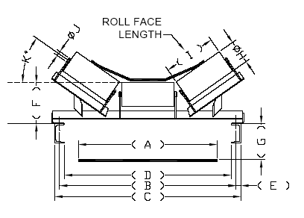  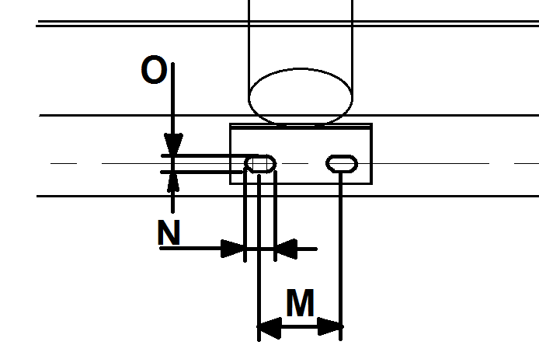OFF-SCALE FOOT BOLTING PITCH DETAILS (See Note 1 below):  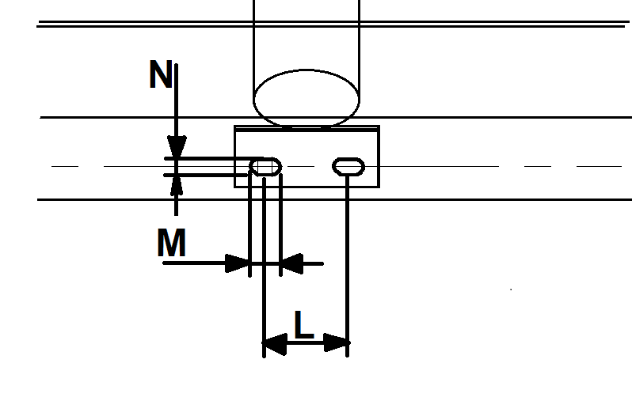  Notes:  - The idler foot bolting pitch sketch above is only to be completed when the idlers are not supplied by Process Automation.  - The On-Scale idler foot bolting pitch Interface to the PA scale is 250mm (Dim “L”).  - Refer to QD-250 for Single Roll Idlers & QD-252 for 5 Roll Idlers. |  |  |  |  |  | DIM | MEASURED DIM
 |  |  |  |  |  | A = |  | mm
 |  |  |  |  |  | B = |  | mm
 |  |  |  |  |  | C = |  | mm
 |  |  |  |  |  | D = |  | mm
 |  |  |  |  |  | E = |  | mm
 |  |  |  |  |  | F = |  | mm
 |  |  |  |  |  | G = |  | mm
 |  |  |  |  |  | H = |  | mm
 |  |  |  |  |  | I = |  | mm
 |  |  |  |  |  | J = |  | mm
 |  |  |  |  |  | K = |  | deg
 |  |  |  |  |  | L = |  | mm
 |  |  |  |  |  | M= |  | mm
 |  |  |  |  |  | N= |  | mm

LOADING CONDITIONS
Product conveyed
More than one different type of material conveyed?
More than one different type of material conveyed? | Yes No |  | (Mark Choice)
Loading continuous? ($*$- see note below)
Loading continuous? ($*$- see note below) | Yes No |  | (Mark Choice)
Loading uniform? ($*$- see note below)
Loading uniform? ($*$- see note below) | Yes No |  | (Mark Choice)
$*$ - If “no” to any of the two questions above, please specify maximum instantaneous belt loading (kg/m)
Severe vibration?
Severe vibration? | Yes No |  | (Mark Choice)
 | Maximum |  |  | Normal |  |  | Minimum
Calibration Capacity (t/h)
Belt Loading (kg/m)
Material bulk density (kg/m³)
Material surcharge angle (degrees)
Particle size (mm)
Moisture content (%)
Conveyor belt speed (metres/second)

Application Data Sheet: EMB230 Conveyor Scale with 3 Roll Troughed Idlers | Page 2 of 5

CONVEYOR CONDITIONS
Conveyor incline angle (degrees) at point of scale installation
Conveyor (normal) idler pitch (mm)
Scale idler pitch (mm) – (preferred: 1000mm)
Conveyor fed by
Conveyor take-up type: * |  |  |  | Gravity Screw Hydraulic None
On which side of the conveyor is the walkway, when viewed in the direction of belt travel? |  |  |  | LHS RHS (Mark Choice)
Distance from centre of scale to tail pulley |  |  |  |  |  |  |  |  | m
Distance from centre of scale to head pulley |  |  |  |  |  |  |  |  | m
Distance from end of infeed skirt-boards to 1st weigh idler |  |  |  |  |  |  |  |  | m
Expansion joints at installation point to be welded? |  |  | Yes No |  |  |  |  |  |  | (Mark Choice)
Is there a curve in the belt? |  |  | Yes No |  |  |  |  |  |  | (Mark Choice)
(If yes, dimensioned/scaled drawing is mandatory)
Are there any trippers on the conveyor belt? |  |  | Yes No |  |  |  |  |  | (Mark Choice)
Are there multiple feed points? |  |  | Yes No |  |  |  |  |  | (Mark Choice)
Is it a reversible belt? |  |  | Yes No |  |  |  |  |  | (Mark Choice)
Is the scale exposed to wind? |  |  | Yes No |  |  |  |  |  | (Mark Choice)
What is the belt thickness (or class & number of plies)? |  |  |  |  |  |  |  |  | mm
Is the belt steel cored? |  |  | Yes No |  |  |  |  |  | (Mark Choice)
Calibration Method: | Theoretical Test Weights* Belt Cut Bulk Material Test
In-accuracy allowable |  |  |  |  |  |  |  |  | %
Power supply available |  | 220VAC 50/60Hz 110VAC 50/60Hz 24VDC |  |  |  |  |  |  |  |  |  |  |  |  |  |  |  |  |  |  | (Mark Choice)
Environmental temperature (°C) |  |  |  |  | (Maximum) |  |  |  |  |  |  |  | (Normal) |  |  |  |  |  |  |  |  | (Minimum)
Hazardous location at Enclosure / Transmitter? |  | Yes No |  |  |  |  |  |  |  |  |  |  |  |  |  |  | (Classification)
Hazardous location at installation of Belt? |  | Yes No |  |  |  |  |  |  |  |  |  |  |  |  |  |  | (Classification)
UniproV Enclosure |  | Double Door Mild Steel (IP66)  Double Door 316 Stainless Steel (IP66) Polycarbonate (IP66)
Is welding on stringers permissible for installation purposes? |  |  |  |  |  | Yes No

GENERAL OPTIONS
Calibration test weight required?* |  |  | Yes No | (Mark Choice)
Manual test weight lifting system required?* |  |  | Yes No | (Mark Choice)
Automated test weight lifting system required?* |  |  | Yes No | (Mark Choice)
Certification “Legal for Trade” required?* |  | Consult Factory
Paint requirements? | PA Proprietary (Blue) Galvanized Other (as per attached) None
Stainless Steel Option | Stainless Steel Grade 304 316
Constant voltage transformer required? |  |  | Yes No | (Mark Choice)

APPLICABLE ONLY WITH SCALE UPGRADE
G-Dimension of torque transmitter: |  | mm
Existing Scale Mounting Centers: |  | mm
Previous SO Number:
Scale duty version: Standard Duty (50mm) | Yes No |  | (Mark Choice)
Scale duty version: Heavy Duty (76mm) | Yes No |  | (Mark Choice)

SPECIAL REQUIREMENTS

Application Data Sheet: EMB230 Conveyor Scale with 3 Roll Troughed Idlers | Page 3 of 5

SKETCH OF CONVEYOR (Side View)
or alternatively attach a drawing (ACAD .dwg or .pdf format) of the conveyor
(Paying specific attention to indicate the position of the curves with respect to the proposed installation position.)
Kindly note that this information is critical to the correct placement of the scale in the conveyor and any omissions could affect the scale performance

Application Data Sheet: EMB230 Conveyor Scale with 3 Roll Troughed Idlers | Page 4 of 5

INPUT AND OUTPUT REQUIREMENTS
STANDARD I/O
Type | Typical Variable
Analogue Output | Rate
Digital Output 1 | Totaliser pulses
Digital Output 2 | Allocatable
Digital Input | Allocatable
ADDITIONAL (OPTIONAL) EXPANSION I/O (TICK A MAXIMUM OF FOUR)
GENERAL |  | Type | Yes |  |  | No
Totaliser pulses |  | Digital Output
System healthy |  | Digital Output
SIGNALS
Rate |  | Analogue Output
Speed |  | Analogue Output
Load |  | Analogue Output
ALARMS
General (active when any assigned alarm is active) |  | Digital Output
Speed high |  | Digital Output
Speed low |  | Digital Output
Speed general (high or low) |  | Digital Output
Load high |  | Digital Output
Load low |  | Digital Output
Load general (high or low) |  | Digital Output
Rate high |  | Digital Output
Rate low |  | Digital Output
Rate general (high or low) |  | Digital Output
AUTOMATED TEST WEIGHT
Activate |  | Digital Output
Position Feedback 1 |  | Digital Input
Position Feedback 2 |  | Digital Input
RATE PID CONTROLLER
Deviation low |  | Digital Output
Deviation high |  | Digital Output
Deviation general (high or low) |  | Digital Output
Control Output |  | Analogue Output
Setpoint Input |  | Analogue Input
Run Feedback |  | Digital Input
SECOND PID CONTROLLER
Deviation low |  | Digital Output
Deviation high |  | Digital Output
Deviation general (high or low) |  | Digital Output
Control Output |  | Analogue Output
Setpoint Input |  | Analogue Input
PV Input |  | Analogue Input
Run Feedback |  | Digital Input
AUXILIARY I/O
Digital Output |  | Quantity: (Maximum 4)
Digital Input |  | Quantity: (Maximum 4)
Analogue Output |  | Quantity: (Maximum 2)
Analogue Input |  | Quantity: (Maximum 2)

Application Data Sheet: EMB230 Conveyor Scale with 3 Roll Troughed Idlers | Page 5 of 5
INPUTS AND OUTPUTS - NOTES
Digital Outputs are available with an electromechanical relay or a solid state relay. The electromechanical relay has change over contacts rated at 24 VDC, 0.5 Amp. The solid state relay has normally open contacts rated at 24 VDC/VAC, 80mA. The solid state relay is typically used for high pulse rate applications (Maximum pulse rate 1000 pulses per second with typically 50% pulse distortion).
Digital Inputs are optically isolated & require 10-40 VDC, 10mA.
Analogue Outputs are optically isolated and capable of driving a 0/4-20 mA into 1kΩ maximum (cable resistance and load).
Analogue Inputs are optically isolated (4-20 mA or 0-10 VDC jumper selectable).

SERIAL COMMUNICATIONS (Select one only)
PROFINET-IO® | Yes No
Profibus® DP | Yes No
Profibus® PA | Yes No
EtherNetIP® | Yes No
ControlNet® | Yes No
DeviceNet® | Yes No
Modbus® TCP/IP (Ethernet) | Yes No
Modbus® | Yes No

CONFIRMATION OF TECHNICAL DETAILS AS SET OUT ABOVE (requirement of ISO 9000/9001)
Print Name: |  |  | Designation:
Signature: |  |  | Date:

FOR OFFICE USE
Scale model purchased
Weigh duty idlers purchased:* |  |  |  | Yes No |  |  | Qty
Dimension "G" selected:* |  |  |  |  |  |  | mm
Load cell capacity selected:* |  |  |  |  |  |  | kg
Scale idler pitch selected:* |  |  |  |  |  |  | mm
Additional requirements:

FOR OFFICE USE ONLY (SALES AND PROJECTS)
Initial ADS amended by Sales or Client |  | Yes No
IF YES | Description of Changes
IF YES | Revision | Rev1 Rev2 Rev3 Rev4 Rev1 Rev5

