APPLICATION DATA SHEET: WEIGH DUTY IDLER(S) – 5 ROLL
Page 1 of 2
Quote Reference:
Customer: |  |  |  |  |  |  |  |  | End-User:
FOR EXISTING PA BELT SCALE SYSTEM*
*Tag Name:
*Scale Model: |  |  |  |  |  |  |  | *Previous SO Number:
Note: The information on the Idlers can be obtained from Unipro – View or print from Application Data stored in EEPROM.
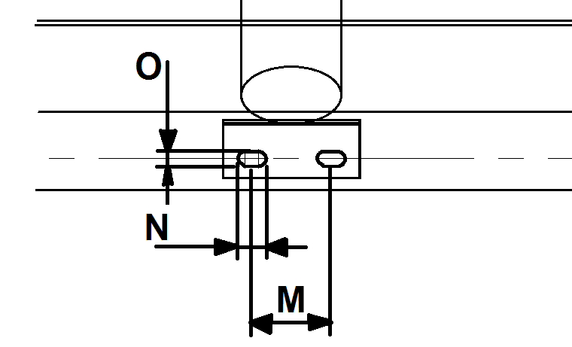OFF-SCALE FOOT BOLTING PITCH DETAILS (See Note 1 below):  Notes  1.) The idler foot bolting pitch sketch above is only to be completed when the idlers are not supplied by  Process Automation.  2.) The On-Scale idler foot bolting pitch interface to the PA scale is 250mm (Dim “M”).  3.) Refer to QD-259 of 3-Roll Idlers. |  |  |  |  |  |  |  |  |  |  |  |  |  |  |  |  | DIM | MEASURED DIM
 |  |  |  |  |  |  |  |  |  |  |  |  |  |  |  |  | A = |  |  | mm
 |  |  |  |  |  |  |  |  |  |  |  |  |  |  |  |  | B = |  |  | mm
 |  |  |  |  |  |  |  |  |  |  |  |  |  |  |  |  | C = |  |  | mm
 |  |  |  |  |  |  |  |  |  |  |  |  |  |  |  |  | D = |  |  | mm
 |  |  |  |  |  |  |  |  |  |  |  |  |  |  |  |  | E = |  |  | mm
 |  |  |  |  |  |  |  |  |  |  |  |  |  |  |  |  | F = |  |  | mm
 |  |  |  |  |  |  |  |  |  |  |  |  |  |  |  |  | G = |  |  | mm
 |  |  |  |  |  |  |  |  |  |  |  |  |  |  |  |  | H = |  |  | mm
 |  |  |  |  |  |  |  |  |  |  |  |  |  |  |  |  | I = |  |  | mm
 |  |  |  |  |  |  |  |  |  |  |  |  |  |  |  |  | J = |  |  | mm
 |  |  |  |  |  |  |  |  |  |  |  |  |  |  |  |  | K = |  |  | deg
 |  |  |  |  |  |  |  |  |  |  |  |  |  |  |  |  | L= |  |  | deg
 |  |  |  |  |  |  |  |  |  |  |  |  |  |  |  |  | M= |  |  | mm
 |  |  |  |  |  |  |  |  |  |  |  |  |  |  |  |  | N= |  |  | mm
 |  |  |  |  |  |  |  |  |  |  |  |  |  |  |  |  | O= |  |  | mm
SCALE
Type |  |  |  |  |  | Accuweigh Easyweigh EC |  |  |  |  |  |  |  |  |  | (Mark Choice)
On which side of the conveyor is the walkway, when viewed in the direction of belt travel? |  |  |  |  |  | LHS RHS (Mark Choice)
APPLICATION DETAILS
Throughput (t/h)
Particle size (mm)
Material bulk density (kg/m3)
Belt Speed (m/min)
FRAMES Page 2 of 2
Quantity Required - On-scale:
Quantity Required - Off-scale:
Stringer Mounting Centres (mm):
Base angle size: (mm):
Centre Roll Height (mm):
Troughing Angle (degrees):
Slot Width (mm):
Stainless Steel Option? |  |  |  |  |  | Yes No |  |  |  |  | (Mark Choice)
IDLER ROLLS
Quantity Required:
Material: |  |  |  |  |  | HDPE Steel |  |  |  |  |  |  |  | (Mark Choice)
Shaft End: |  |  |  |  |  | Open Type Closed Type |  |  |  |  |  |  |  | (Mark Choice)
Roll Diameter (mm):
Idler Shaft Diameter (mm):
Gauge length (mm):
Across Flats (A/F) (mm):
Stainless Steel shaft option? |  |  |  |  |  | Yes No |  |  |  | (Mark Choice)
Dynamic balancing required? |  |  |  |  |  | Yes No |  |  |  | (Mark Choice)
GENERAL FRAME OPTIONS
Special painting? |  |  |  |  |  | PA Proprietary (Blue) Galvanized Other (as per attached) None
Galvanising required? |  |  |  |  |  | Yes No |  |  |  | (Mark Choice)
Stainless Steel option? |  |  |  |  |  | Yes No |  |  |  | (Mark Choice)
SPECIAL REQUIREMENTS
CONFIRMATION OF TECHNICAL DETAILS AS SET OUT ABOVE (requirement of ISO 9001)
Print Name: |  |  |  |  |  |  |  |  |  | Designation:
Signature: |  |  |  |  |  |  |  |  |  | Date:
FOR OFFICE USE
Additional requirements:

